**WIA2001/WIB2001**

**DATABASE**

**SEM 1, 20116/2017**

**Tutorial 4**

1. Remove repeating groups from the following table. Explain your answer:

**Class_Enrollment**

|  |  |  |  |
| --- | --- | --- | --- |
| **Class Code** | **Class Description** | **Student Number** | **Name** |
| 503 | Mgt Info Systems | 00001 | Masters, Rick |
|  |  | 00003 | Smith, Steve |
|  |  | 00005 | Jones, Terry |
| 540 | Quant Methods | 00002 | Wallace, Fred |
|  |  | 00003 | Smith, Steve |
|  |  | 00004 | Nurk, Sterling |

2. Examine the table shown below.

| *branchNo* | *branchAddress* | *telNos* |
| --- | --- | --- |
| B001 | 8 Jefferson Way, Portland, OR 97201 | 503-555-3618, 503-555-2727, 503-555-6534 |
| B002 | City Center Plaza, Seattle, WA 98122 | 206-555-6756, 206-555-8836 |
| B003 | 14 – 8th Avenue, New York, NY 10012 | 212-371-3000 |
| B004 | 16 – 14th Avenue, Seattle, WA 98128 | 206-555-3131, 206-555-4112 |

1. Why is this table not in 1NF?
2. Describe and illustrate the process of normalizing the data shown in this table to third normal form (3NF) – answer in table form.
3. Identify the primary, alternate and foreign keys in your 3NF relations.
4. The dependency diagram in Figure 4 indicates that authors are paid royalties for each book that they write for a publisher. The amount of the royalty can vary by author, by book, and by edition of the book.

Figure 4: Book royalty dependency diagram

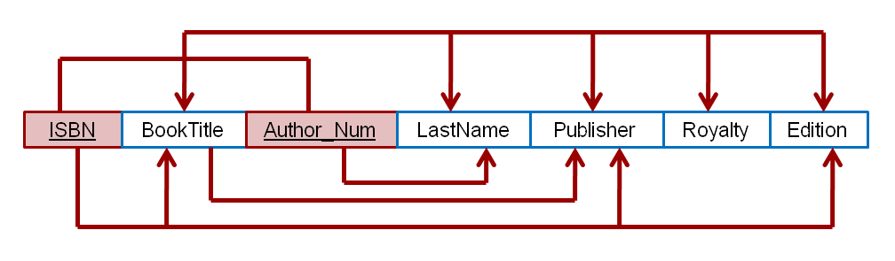

a**.** Based on the dependency diagram, create a database whose tables are at least in 2NF, showing the dependency diagram for each table.

b. Create a database whose tables are at least in 3NF, showing the dependency diagram for each table.